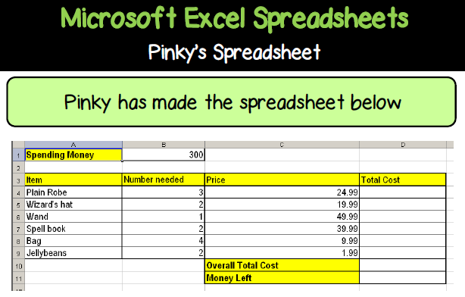
1. What information does this spreadsheet show?

2. Write down the formula that be used in:
Cell D5 to calculate the Total Cost of Wizard’s Hats:
Cell D10 to calculate the Overall Total Cost:
Cell D11 to calculate the Money Left:

3. In the spreadsheet above, a new row will be inserted above row 9 as Pinky now has to buy Frog Legs as part of her shopping list. How will the formula in cell D10 change?
Write out the new formula here:

