Name:

Computer Literacy – Programming Languages

- A ______is a formal computer language designed to communicate instructions to a computer to create programs. Some examples of programming languages are ______, ______, and ______.

- All programing languages have common features. Computer programming languages have
- ______, ______, ______, ______, and ______.

- One or more ______ make up a computer program. The computer runs a program by reading and understanding each statement line by line.

- ______ are used to store information to be referenced and manipulated in a computer program. When a program is executed or run, the variable is replaced with real data.

- ______ are very important for programming. A condition can be used to ensure that your program works. Conditions also allow for branching, depending on if the condition is met or not. The easiest condition is an ______.

- ______ are repetitive conditions where one variable in the loop changes. When creating a program, you can use a loop to instruct the computer to run one or more statements more than once.

- 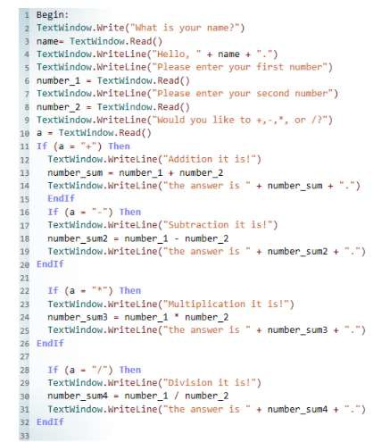In computer programs, a______is an explanation within the program statements. Comments are added with the purpose of making the source code easier for users to understand. Comments simply ______.

