CENTRAL PROCESSING UNIT
INSTRUCTION CYCLE
FETCH
instructions from memory
DECODE
instructions to be processed
EXECUTE
instructions
to perform the task
Arithmetic Logic Unit (ALU)
–
Performs
arithmetic and logical computations
Control Unit
–
Executes and stores ALU
results. Performs the Instruction Cycle.
Registers
–
Temporary storage areas in
the processor that accept, store, and send
out data or instructions, as directed by
the control unit.
Name ____________________________________

INFORMATION PROCESSING
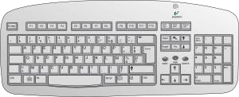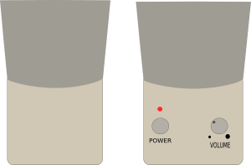
INPUT STORE OUTPUT
CPU
&
PROCESS DATA

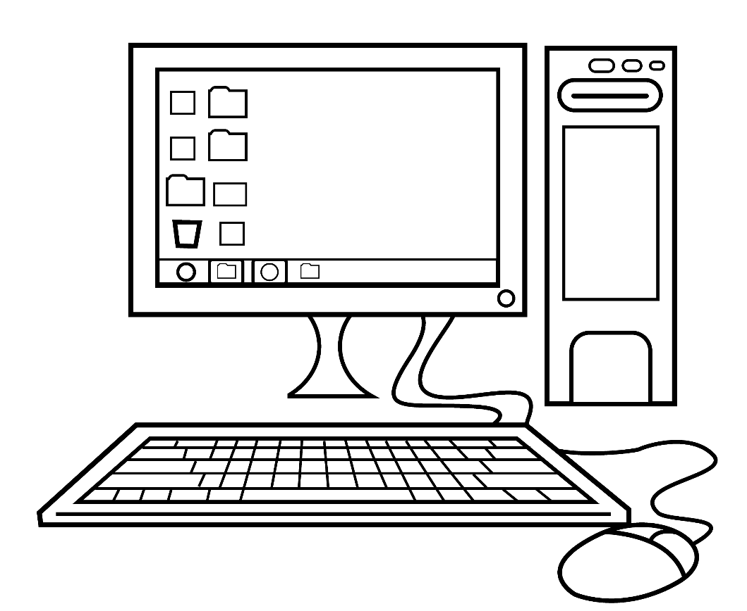
LABEL PARTS OF THIS COMPUTER
LABEL AS INPUT, OUTPUT, or BOTH
1.
Speakers
_____________
2.
Keyboard
_____________
3.
Printer
_____________
4.
Webcam
_____________
5.
Mouse
_____________
6.
CD Player
_____________
7.
Monitor
_____________
8.
Flash Drive
_____________
9.
Scanner
_____________
10.
Headset
_____________

SOFTWARE
Software is a set of machine-readable instructions that the computer can process. Programs and applications are software. The computer’s operating system (OS) is software.
List some of the software on your computer.
___________________ ___________________
___________________ ___________________
___________________ ___________________

HARDWARE
Hardware is the physical pieces of a computer.
List all the hardware of your computer. (Hint: they could include more than keyboard, monitor, mouse and CPU).
_________________________________ _____________________________________ _________________________________ _____________________________________ _________________________________ _____________________________________
_________________________________ _____________________________________
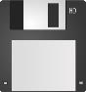
DESCRIBE THE FUNCTION PERFORMED BY THESE
1.
_________________________
2.
_________________________
3.
? _________________________
4.
__ ________________________
5.
________________________
6
. ________________________
SYMBOLS IN A SOFTWARE APPLICATION

Machine language is a set of instructions used by the computer.
The language is binary code consisting of 0’s and 1’s. High
-
level
languages have to be interpreted by another language, called an
assembler or compiler, before being used by the CPU.
A bit is the smallest unit of data in a computer. It is represented
by either a 0 or a 1.
A byte is represented by eight characters. Most computers
represent data in bytes. For example, the computer processes
01100001
as an “a”, and 01000001 as an “A”.
Larger amounts of data is represented by kilobytes (1,024
bytes), megabytes (1,048,576 bytes), and gigabytes
(1
,073,741,824 bytes
).
Metaphorically, your computer is a busy bee processing 0’s and
1
’s to execute tasks and give you results.

LOCAL AREA NETWORKS
A local area network (LAN) is a small group of computers sharing a common communication link. This may be a school or a company LAN. You may have a LAN in your home if you have multiple computers that can share data. Local area networks are usually connected to a main computer known as a server. The server provides data to be shared between the computers connected to the LAN. A print server allows multiple users to access the same printer and a file server is used to store and access files
among multiple computers.

THE INTERNET
The Internet spans the globe, connecting millions of computers. It carries electronic mail, file sharing, telephony services, and the World Wide Web. The World Wide Web is a subset of the Internet.
In order to connect to the Internet, you need access through an Internet Service Provider.
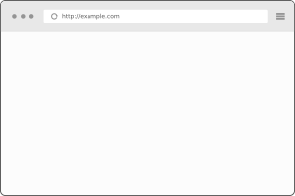
Depending on the URL requested at the top, webpage information will be displayed back to you from the Internet.

USING THE INTERNET
- URL – The reference address to a resource on the world wide web. For example:
http://myexample.com
The http is the protocol identifier and myexample.com is the resource name. Notice they are separated by a semi-colon and two forward slashes
- SEARCH ENGINE– You select the keyword(s). A program identifies and selects items from a database. The web pages of the search are displayed, for you to select.
- WEB BROWSER – A software application used to
retrieve, display, and transfer information from a resource on the World Wide Web.
- HOME PAGE – The first page that comes up when you execute a web browser.
- HTML – Hypertext Markup Language is a set of tags used to create web pages. HTML tags display
the font, color, hyperlinks, and graphics of text files.

ACRONYMS
- CD – Compact Disc
- CD-R – Compact Disc Recordable
- CD-ROM – Compact Disc Read-Only Memory
- CD-RW – Compact Disc Re-writable
- CPU – Central Processing Unit
- DBMS – Database Management System
- FTP – File Transfer Protocol
- HTML – Hypertext Markup Language
- HTTP – Hypertext Transfer Protocol
- HTTPS – Hypertext Transfer Protocol Secure
- I/O – Input/output
- ISP – Internet Service Provider
- JPEG – Joint Photographic Experts Group
- Kbps – Kilobits Per Second
- LAN – Local Area Network
- MIPS – Million Instructions Per Second
- MMS – Multimedia Messaging Service
- MP3 – MPEG-1 Audio Layer-3
- PC – Personal Computer
- PDF – Portable Document Format
- RAM – Random Access Memory
- URL – Uniform Resource Locator
- USB – Universal Serial Bus
- VGA – Video Graphics Array
- WWW – World Wide Web 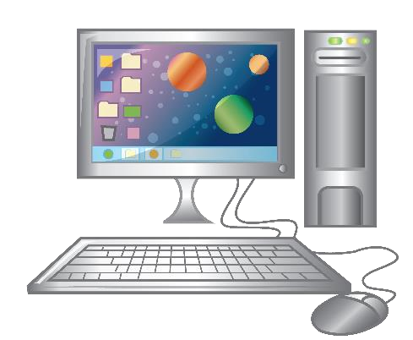

Name ____________________________________ ACRONYMS
Write the acronym that pertains to this description.
- A monitor, system unit, a mouse, and keyboard. _________
- Can be accessed by a web browser. _________
- A file requiring Adobe Reader. __________
- An address on the Internet. _________
- A network of computers linked together. ________
- A disc that can record data. _________
- Connects devices, such as printers to a computer. _______
- Company you pay to get internet access. ________
- Runs the operating system and all applications. _________
- Measurement for data transfer rates. _________
- A compressed audio format. ______
- A program that manages data. ______
- Memory chips to read data. _____
- Round discs that hold data. ____
- Language used to create webpages. _____
- A disc that can be written on multiple times. ______
- Describes sending data in and out of computer. ____
- Sends messages, videos, images on a mobile phone. ____
- A disc that data on it cannot be changed. _____
- Standard interface for a monitor. ______
- Measurement of the processor in the computer. ____
- Defines rules for transferring data over web pages. _____
- Format for compressing pictures. _____
- Set of rules for transferring files on the internet. ____
- Rules to encrypt data for security purposes. ______

FILL IN THE BLANKS
- Upon exiting an application, you should always ________ your work.
- The part of the CPU that performs arithmetic computations is known as _______________________________.
- The three phases of the Information Processing Cycle are
____________, _________________________, and _____________.
- The part of the CPU that performs the Instruction Cycle is the _____________________.
- A small group of computers that are connected by a common communication link is known as ____________________________.
- An example of input hardware is __________________________.
- An example of output hardware is _________________________.
- The program used to access the Internet is called a ________________.
- Web pages are written in text files using ________________________.
- In order to perform certain functions within an application, you can use the ________ key instead of using a mouse.
- An application you can use to find web pages using key words is called a ___________________________.
- The address of a web page is called the ________________________.

TRUE OR FALSE
- ___ The CPU receives, processes, stores, and transfers data.
- ___ Speakers are an example of output hardware.
- ___ Arithmetic calculations are performed in the control unit.
- ___ VGA is an interface to the keyboard.
- ___ A scanner is an example of an output device.
- ___ Data can be seen as output on a monitor.
- ___ This is an example of a URL: https//mypage.com.
- ___ A LAN is a group of computers that can share data.
- ___ The Ctrl key can be used with other keys to do tasks.
- ___ PDF is an example of a file type.
- ___ An ISP is not needed in order to access the internet.
- ___ HTML is used to create web pages.
- ___ Using Ctrl + X keys will print your work.
- ___ The CPU uses binary code to execute instructions.
- ___ A byte is a unit of measure consisting of eight bits.
- ___ A kilobyte is 1,000 bytes.
- ___ Clicking on the “?” in an application will provide you with help for the application you are in.
- ___ The internet can only be accessed by a search engine.
- ___ DBMS stands for database maintenance service.
- ___ A print server allows multiple users access to use a LAN printer.
- ___ Electronic mail is transmitted over the internet.
- ___ The internet is part of the world wide web.
- ___ A CD-ROM is a disc that can be written over multiple times.
- ___ A USB is a port used to connect hardware to the CPU.
- ___ RAM is hardware that the CPU can access randomly rather than sequentially.

